Chiara Rossi 5^A accoglienza 29th January2019

STILL LIFE WITH CAKE.
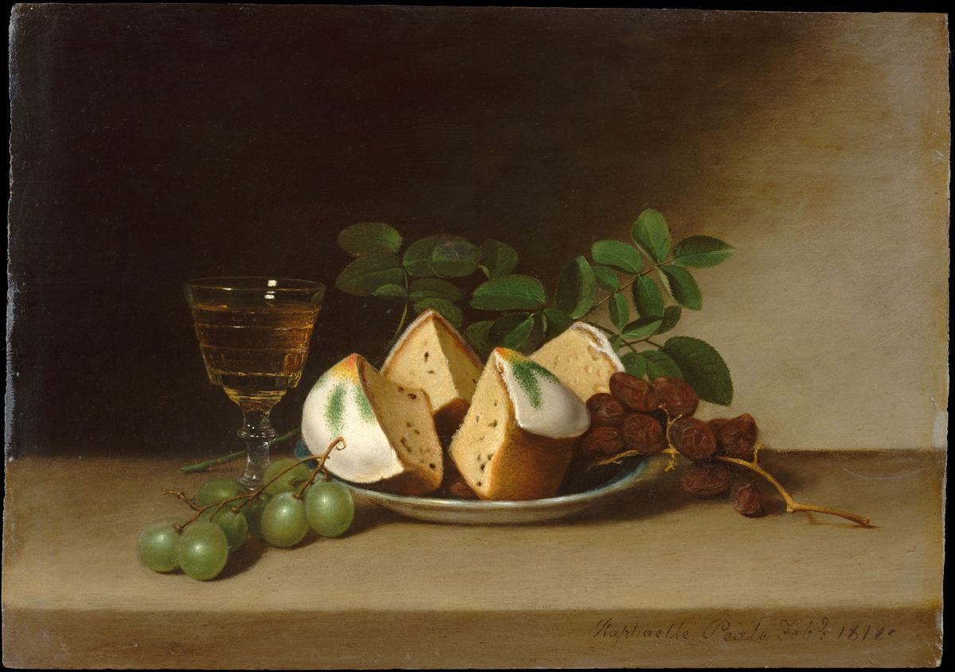
The painting is the “Still life with cake” by Raphaelle Peale and it is located in the Met Museum in New York.
This painting was made in the 1818 with oil on wood.
In this picture I can see, in the foreground, a plate with inside pieces of cake, raisin and branches of leaves.
I think that the pieces of cake were various pieces of cheese.
Next to the plate there are a glass of sparkling wine probably and white grapes.
The background is of brown colour and with shadows.
WHAT DOES THIS PAINTING REALLY MEAN?
Peale's tightly grouped still lifes are often permeated with a delicate melancholy he was an alcoholic.

THE STARRY NIGHT.
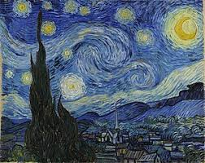
The painting is the “Starry night” by Vincent Van Gogh and it is located in the Moma Museum in New York.
This painting was made in the 1889 with oil on canvas.
In this picture I can see a blurred and moving image of the stars, the moon, the houses of a country.
The colours of the sky are mixed between blue, light blue and the yellow of the moon and the stars.
This is one of my favourite painting.
WHAT DOES THIS PAINTING REALLY MEAN?
Van Gogh's night sky is a field of roiling energy. The village is a place of quiet order. The earth is flamelike cypress, a tree traditionally associated with graveyards and mourning. But it was not ominous for van Gogh.
The village was partly invented, and the church spire evokes van Gogh's native land, the Netherlands.
This masterpiece represents a sad period of the life of the artist.

THE PALAZZO DUCALE.
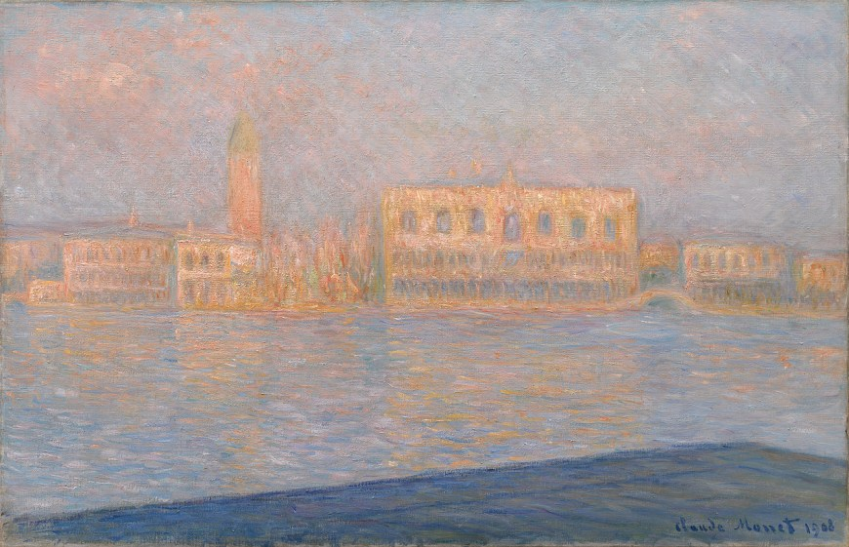
The painting is the “Palazzo Ducale” by Claude Monet and it is located in the Guggenheim Museum in New York.
This painting was made in the 1908 with oil on canvas.
In this picture I can see a blurred image of monuments.
The main colours are the orange or light brown mixed with the light blue.
It is very simple.
There are some shades.
WHAT DOES THIS PAINTING REALLY MEAN?
This is the Doge's Palace, Seen from San Giorgio Maggiore, in Venice.

