Chiara Rossi 5^A accoglienza 12th December 2018
5 TOP PAINTINGS OF THE NATIONAL GALLERY
A YOUNG WOMAN STANDING AT A VIRGINAL.
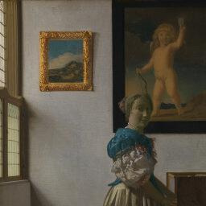
This is a masterpiece of Johannes Vermeer, made with Oil on canvas and it is located in the 16 room of the National Gallery in London.
The period time is between the 1632 and the 1675.
In this painting there is a young woman standing in front of the pianoforte.
The woman is playing the piano.
The woman dresses an ancient light-brown gown with a blue or green shawl.
She has blonde hair gathered in a chignon.
In the background, there are two paintings, one with a nude man who has blonde hair and one with a landscape inside.
On the left, there is a window and the wall is white.
In addition, there is a blue chair near the woman.
The floor is blue and white.
The painting can have the traditional association of music and love.
SUNFLOWERS.
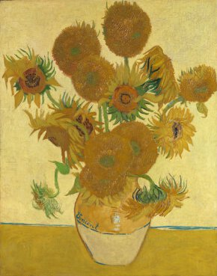
This is one of the famous masterpiece of Vincent van Gogh, made with Oil on canvas and it is located in the 41 room of the National Gallery in London.
The period time is between the 1853 and the 1890.
In this painting, you can admire a vase of sunflowers and the main colour is yellow.
This is one of my favourite painting.
Van Gogh intended to decorate Gauguin's room with these paintings in the so-called Yellow House that he rented in Arles in the South of France.
THE FIGHTING TEMERAIRE
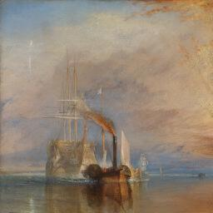
This is a painting by Joseph Mallord William Turner, made with Oil on canvas, and it is located in the 34 room of the National Gallery in London.
The period time is about 1839.
In this masterpiece, you can admire various shades of colour.
The main colours are light blue, orange, and white.
There is a ship during a war, I think.
Maybe, there was a fire.
The 98-gun ship 'Temeraire' played a distinguished role in Nelson's victory at the Battle of Trafalgar in 1805, after which she was known as the 'Fighting Temeraire'.
The painting was thought to represent the decline of Britain's naval power.
WHISTLEJACKET
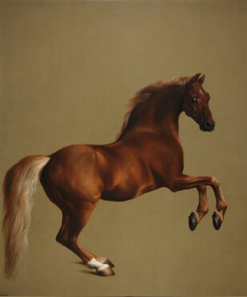
This is a painting by George Stubbs, made with Oil on canvas, and it is located in the 34 room of the National Gallery in London.
The period time is about 1762.
In this painting, you can see a horse, while it is galloping.
The colours are brown and light brown.
Whistlejacket was foaled in 1749. His most famous victory was in a race over four miles for 2000 guineas at York in August 1759.
WINEGLASSES
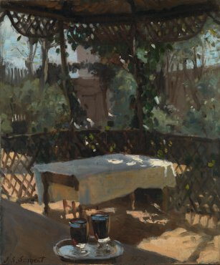
This is a painting by John Singer Sargent, made with Oil on canvas, and it is located in the National Gallery in London.
The period time is between 1856 and 1925.
In this painting, you can admire a wood table with a white tablecloth and near a tray with two glasses of red wine.
The table is surrounded by the nature and an arbour made with wood.
The painting is confusing.
Sargent probably painted this study of a sun-dappled veranda at St-Enogat in Brittany, where he spent the summer of 1875.
The light brushwork reveals the influence of the Impressionists, an artistic tendency.

