Chiara Rossi 5^A accoglienza 18th December 2018

You don’t miss to visit the historic college of Oxford;
You can walk along the ocean at Seven Sisters Country Park or let yourself be captivated by the mysterious atmosphere of Canterbury.
Oxford is famous for its university.
It is located between history and nature and you will be fascinated by the numerous colleges of Oxford University, including the one that became famous as a set of the Harry Potter series.
In addition, you can admire the wonderful Oxford even from the River.
In fact, there is the possibility of taking a cruise on the Cherwell River with picnic on board.

Eastbourne is the starting point to start discovering the famous Seven Sisters, the seven white cliffs that - connecting Eastbourne to the smallest town of Seaford - create the Seven Sisters Country Park.
It is called the famous Park along the Ocean.
The entry is free.
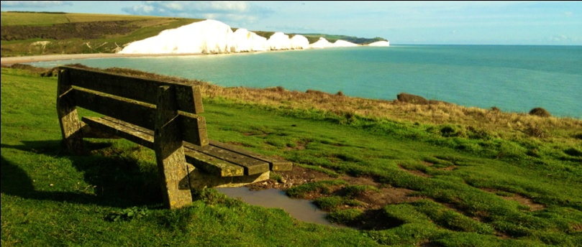

The city of Canterbury is surrounded by spirituality, history and mystery.
We are in the Kent region - known as "The Garden of England" - famous for its breathtaking landscapes and for its cities with ancient and mysterious history.
You don’t miss the big cathedral and the ruined Abbey, with a stop in one of the characteristic pubs or for the bravest, a tea in the company of three ghosts!

Organization: Dream Travel- C.so Risorgimento, 405-28100 Novara (NO), by Chiara Rossi.

