Chiara Rossi 5^A accoglienza 18th December 2018

PERIOD: from 21/12/2018 to 23/12/2018 for 2 people.
ACCOMMODATION: LSE Northumberland House.
It is situated only 3 minutes’ walk from Trafalgar Square, while Buckingham Palace, Parliament Square and The Royal Horseguards are all within a 15-minute walk from this building.
The West End and Covent Garden is just 10-minute walk, and Oxford Street is only a kilometre away.
The total price is € 256, 00 for 2 people and 2 nights.
http://www.lse.ac.uk/student-life/accommodation/halls/northumberland-house
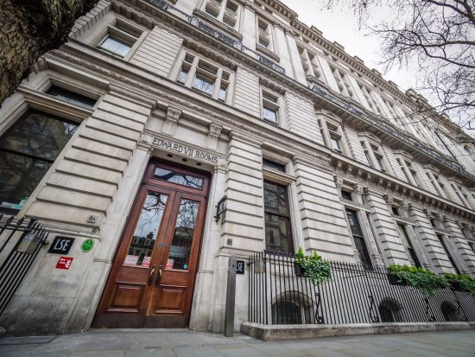

flights:
Departure flight leaves from Milan MXP on 21st Dec 2018 at 7:25 and arrives in London Gatwick at 8:25 (local time). The fare is €37, 67 per person;
Return flight leaves from London Gatwick on 23rd Dec 2018 at 19:40 and arrives at Milan MXP at 22:30 (local time). The fare is €158.25 per person;
The total fare is € 391, 84 for 2 people.
The airlines company is Easy Jet.

WHAT YOU CAN DO:

- Enjoy the Christmas atmosphere at the winter wonderland in Hyde Park.
Admission to winter wonderland is free. Charges apply for rides, ice skating, big top shows, the observation wheel, magical ice kingdom and bar ice.
- Take a romantic walking in the colourful enchanted woodland at Syon Park.
- You can admire the London skyline while skating at skylight, the panoramic ice rink.
- Listen to the candlelight Christmas songs at the royal Albert hall.
- You have to get on board a boat for a happy cruise on the river of Thames with Santa Claus.
The boat departs from tower pier and returns to tower pier.
Tickets price for 2 people: €62, 00.
- You can’t miss to see the wonderful Christmas lights of Oxford Street, the famous shopping street of London.
- Enjoy a homemade dish at the new Christmas market along the Greenwich river wintertime festival.
- You have to taste the Christmas food with a peaceful walking through the beautiful parks of London.
- You can spend an afternoon in the lively Chinatown area.
- you can see award-winning pianist warren mailley-smith at the Piccadilly Christmas concert.
 | PRICES IN EURO | PRICES IN POUNDS
Departure flight | 37,67(x2) = 75,34 | 83,88
Return flight | 158,25(x2) =316,50 | 352,36
Hotel (price is for 2 person and 2 nts) | 256,00 | 285,00
Price for the cruise on the river of Thames for 2 people | 62,00 | 69,00
TOTAL | 709,87 | 790,31
MARK UP 20% | 851,84 | 948,37

